SOFTWARE PRODUCT REQUIREMENTS DOCUMENTATION TIPS



Whether your organization is constructing a brand new program, application, or ecommerce website, the product will want a fixed of well-written necessities to gain a success layout and implementation. Today’s agile improvement environment makes streamlined processes even greater critical, as it's far crucial for each enterprise to construct answers speedy via correct feedback and iterative improvements.

Before you embark in your subsequent project, writing a radical but particular requirements report will enhance the pleasant of the improvement procedure and save you destiny demanding situations with the software program.

The key additives a PRD need to encompass:

• Objective

• Release

• Features

• User flow and layout

• Analytics

• Future work

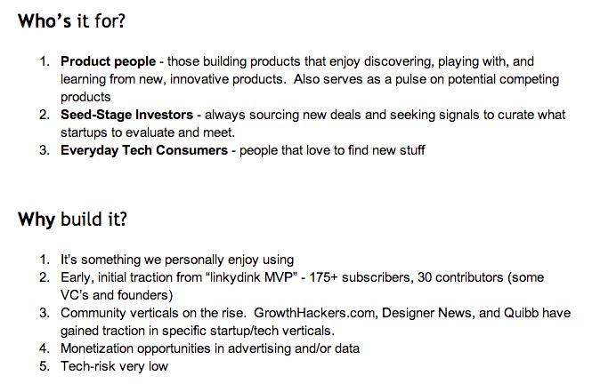

[Source: Product Hunt Product Requirements Document](https://docs.google.com/a/uxpin.com/document/d/1yrU5F6Gxhkfma91wf_IbZfexw8_fahbGQLW3EvwdfQI/edit)

**Defining Your Document Necessities**

Each development crew need to start writing their product requirements report by means of answering the basics. This consists of the who, what, and why at the back of the application. Determine the software program’s purpose, benefits, and an appropriate person of the product. Your crew need to additionally outline how will it streamline or enhance the modern processor introduce a brand new one.

In addition, each product requirements report wishes to encompass consumer personas, a sitemap, and web page descriptions. It need to additionally have non-practical necessities, risks, and implications for destiny iterations. While wireframes aren't required, they may be recommended. This remaining detail is useful as it permits your crew to visualise every part of the app or software program product.

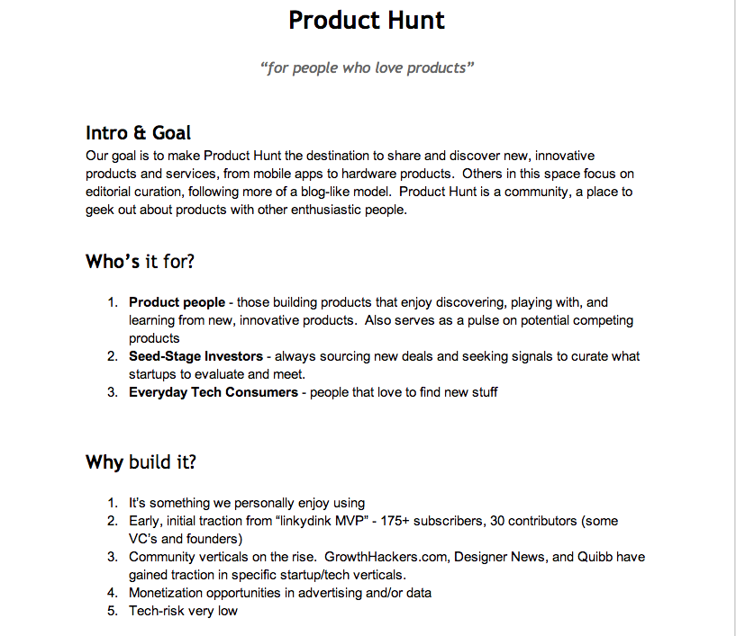

## Source: [Product Hunt Product Requirements Document](https://docs.google.com/a/uxpin.com/document/d/1yrU5F6Gxhkfma91wf_IbZfexw8_fahbGQLW3EvwdfQI/edit)

**Describe the Product Features**

The functions phase is the body of the PRD.Features ought to be defined on the subject of the interplay layout and person experience to present engineering the maximum flexibility. More importantly, you ought to map functions to product objectives (called requirements traceability) in order that the enterprise effect may be sincerely understood if a person cuts a sure function at some stage in improvement. Ranking those featureswill additionally assist you prioritize in case there’s scheduling shifts otherwise you find out a few functions need to get replaced as you development in improvement. To research greater approximately a number of today’s maximum a success agencies prioritize functions, test out the Guide to Minimum Viable Products.

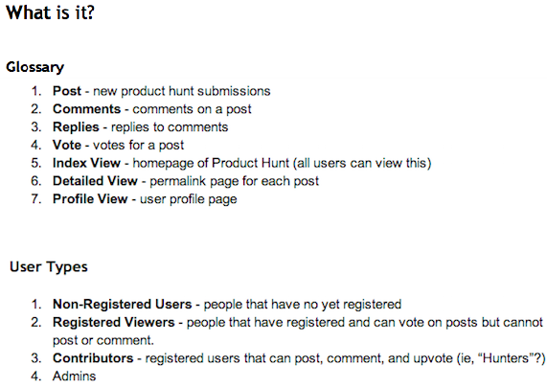

*[Source: Product Hunt Product Requirements Document](https://docs.google.com/a/uxpin.com/document/d/1yrU5F6Gxhkfma91wf_IbZfexw8_fahbGQLW3EvwdfQI/edit" \t "_blank)*

**Determine the Timeline**

Every product launch wishes a aim launch date — despite the fact that it’s a tough estimate.

This need to provide you with flexibility to evolve to a alternate in priorities. But it need to limition scope creep via way of means of restricting what number of functions stakeholders can add.

Managing the discharge procedure — and hitting that focus on launch date — may be intricate.

 

**Make Sure Stakeholders Review It**

When you create a PRD, it’s crucial that key stakeholders evaluation the report.

This may be intricate whilst you’re handling a necessities report in Microsoft Word.

It’s a first-class exercise to have a imperative answer wherein you may manipulate necessities opinions online. Then, you may make certain that everybody is calling on the maximum current model of the report. And you may cross returned and track how things have changed.

It’s additionally critical that everybody worried in improvement of the product is aware of what’s at the PRD. It need to be shared with all people from developers to testers to managers.

